Patient Acuity in the ER
Nichole Rodrock
Missouri State University
PSY 527/627

Patient Acuity in the ER
Many different types of patients come to a rural emergency room (ER). Since there is generally not adequate rural healthcare many patients come to the ER for minor complaints that could easily be taken care of by a primary care provider. When a patient first enters the ER they are registered and then seen by a triage nurse. The triage nurse does an initial assessment and determines the patients acuity level also known as an emergency severity index (ESI).
A question has risen about whether the nurses are assigning accurate ESI scores in triage. To determine if the scores are being applied correctly I would like to evaluate how the acuity of patients relates to a few other factors. The questions I wish to review is if there is significance between the acuity level assigned and the length of stay of the patient. I believe that if a patient has a higher acuity they would stay longer in the ER for treatment. Also if there is a higher acuity is there a higher chance of the patient being admitted or transferred as opposed to being discharged home. I am also interested in seeing if there is a correlation between acuity and insurance status. I believe that higher acuities will not have insurance, because patients will wait longer to seek treatment.
METHODS
Subjects
A sample of 20 charts were reviewed from the ER records. Charts were chosen at random and evaluated on the same date. They were chosen from a one month time frame. All information was retrieved from the patient medical charts on file.
Apparatus
Each patients chart was evaluated for 10 different variables. Age, sex, acuity level (ESI), chief complaint, disposition, length of stay, pain level, arrival method and insurance status. Arrival method is if the patient arrived by private vehicle or ambulance and insurance status is gauged either yes or no.
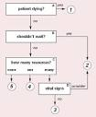
A chief complaint is the presenting problem a patient has. Chief complaints for the sample of 20 charts were chest pain, dental pain, abdominal pain, cough, fever, and breathing problem. The chief complaint helps determine the patient acuity.
The ESI is a five level emergency department triage algorithm that separates patients into five groups from least to most urgent based on patient acuity and resources needed ("Emergency severity index (ESI)," 2011). The more urgent the need the faster the patient should be evaluated by a physician.
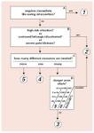
An example of this would be a patient with a headache that would require only a pain shot would be considered a level 4 less urgent patient. While a patient that comes in with shortness of breath and is blue would be a level 1 immediate patient and brought straight back into the ER.
A patient’s pain is level is also evaluated in triage. This is done by using the numerical pain scale. Pain is rated on a scale of 0-10. 0 being no pain and 10 being the worst pain imaginable to the patient.

RESULTS
Basic Results
Gender Male=6 (30%) Female=14 (70%)
Acuity Non-urgent=0 (0%) Less-urgent=9 (45%) Urgent=11 (55%)
Emergent= 0 (0%) Immediate=0 (0%)
Complaint Dental Pain=3 (15%) Abdominal Pain=3 (15%) Cough=4 (20%)
Fever=4 (20%) Breathing Problem=5 (25%) Chest Pain=1 (5%)
Disposition Discharge=17 (85%) Transfer=2 (10%)
Left against medical advice=1(5%)
Length of Stay 0-1 hour=5 (25%) 1-2 hour=7 (35%) 2-3 hour=5 (25%)
over 3 hour=3(15%)
Pain Score 0=4 (20%) 1=0(0%) 2=1 (5%) 3=0 (0%) 4=0(0%) 5=1 (5%)
6=3 (15%) 7=3 (15%) 8=2 (10%) 9=2(10%) 10=4 (20%)
Arrival Method Car=19 (95%) Ambulance=1 (5%)
Insurance Yes=11 (55%) No=9 (45%)
These results show us many things. First of all no patients were classified as non-urgent, emergent or immediate. Also none of the patients rated their pain scores on a level of 0, 1, 3 or 4. I found it interesting that the length of stay was spread out among the patients. More patients arrived by private vehicle than by ambulance. This could be because most patients were not critical. I also found it very interesting that 55% of the patients had insurance.
The results of this study showed that a higher level of acuity affected to patient length of stay in the ER. Of the sample the urgent patients had a 2-3 hour stay of 45.5%, while the less urgent had 0%. The less urgent patient class had a 55.6% level in the 0-1 hour length of stay. Below is the Chi-square test showing significance of acuity and length of stay. At a 0.05 alpha acuity and length of stay is significant with a value of 0.016.

Chi-Square Tests Disposition
 | Value | df | Asymp. Sig. (2-sided)
Pearson Chi-Square | 10.380ª | 3 | .016
Likelihood Ratio | 14.146 | 3 | .003
Linear-by-Linear Association | 6.174 | 1 | .013
N of Valid Cases | 20
a. 8 cells (100.0%) have expected count less than 5. The minimum expected count is 1.35.

The results show that there is no significance between acuity and disposition.

Crosstab
 |  |  | Disposition |  |  | Total
 |  |  | Discharge | Transfer | Left Against Medical Advice
Acuity | Less Urgent | Count | 9 | 0 | 0 | 9
 |  | % within Acuity | 100.0% | 0.0% | 0.0% | 100.0%
 | Urgent | Count | 8 | 2 | 1 | 11
 |  | % within Acuity | 72.7% | 18.2% | 9.1% | 100.0%
Total |  | Count | 17 | 2 | 1 | 20
 |  | % within Acuity | 85.0% | 10.0% | 5.0% | 100.0%
However more urgent patients were transferred than less urgent patients.
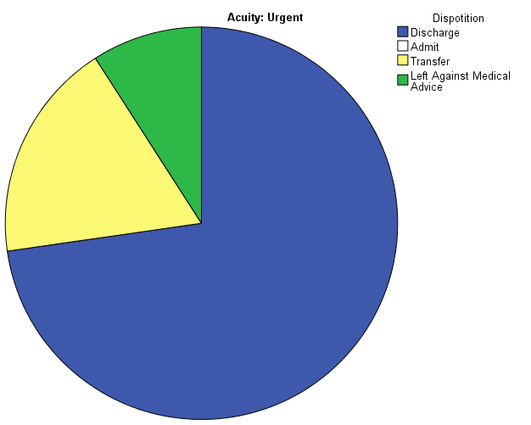
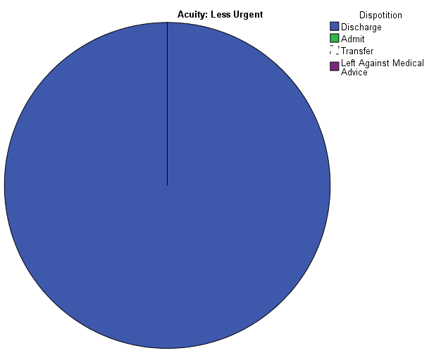

These pie charts show that patients with urgent acuity levels were more likely to

be transferred than less urgent patients.

Acuity and insurance also has no significance. In fact there were more 55.6%

less urgent patients with no insurance, while only 36.4% of urgent patients had no

insurance. The following graphs show more less urgent patients were without

insurance than urgent patients.
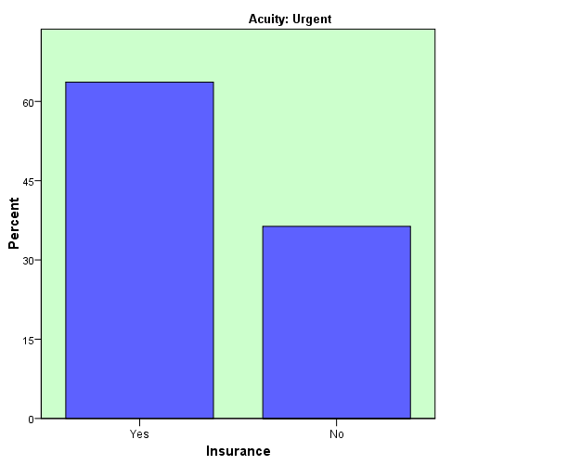
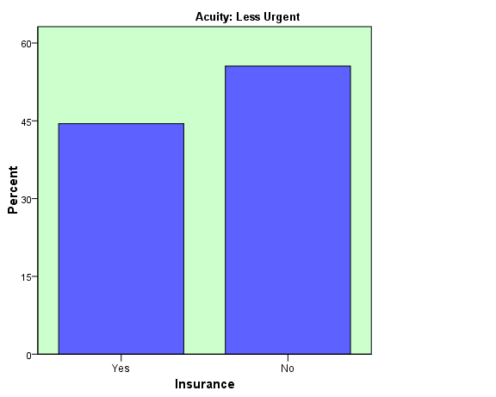

Discussion

According to the data there was a relationship between acuity level and length of stay. The more urgent patients had longer lengths of stay than the less urgent patients. There was no significance between the acuity level and whether the patient had insurance or if the patient was discharged home.
I feel that if a larger sample had been evaluated the results may have been a little different. However since there was such a small sample there were not adequate amounts of patients transferred. The research proves that acuity does have an effect of length of stay however it does not have any correlation with insurance. I do not believe that even with a larger sample size there would be any difference in the results with regards to insurance. After this research I see that the patients do without insurance do not seem to delay care because of it.

References
Emergency severity index (ESI): a triage tool for emergency department. (2011). Retrieved May 5, 2013, from http://www.ahrq.gov/professionals/systems/hospital/esi/esi1.html

